## horizontal line



SHARIK UIK LIVE

v 0.0.1

**─**

Toumi Mustapha Abderrahmane

Full stack web developer & software engeneering student

mohamed djanhlen B 73 number 02

Tiaret, 14000

# Overview Our mini project entitled "Sharik" about WEB Programming aims to put civic technology into practice at Ibn Khaldoun University in Tiaret. to bring out new ideas for practicing environmental protection relying on digital.

# Goals & Objectives

1. Create a website a for ibn khaldoune students , Teachers , staff and everyone in the university
2. Everyone in ibn khaldoune univeristy can participate or contribute in this website
3. Make everyone in the university participate in making ibn khaldoun faculties, classes ... a better place
4. A platforme To share new ideas by creating and managing events , writing blogs , interacting with other user, sharing ideas , and publishing educationel content
5. The website must use gamification to make a positive impact based on **Octalysis – the complete Gamification framework**
6. Encourage socialization and competition using game element
7. A website Easy to use with a beatiful interface
8. A responsive Website work on phones and desktops screens
9. This website can be installed on phones and desktops just like a native app by applying progressive web apps principles
10. This website must load faster without consuming so much data especially for those who use mobile data ( we need to use serviceWorkers, indexedDB , caching and more ...)
11. In This website there is no difference between a student , a teacher or any one who work in the university they can all join this website and they all start as a simple users
12. Everyone start from a simple user and they can get a higher level by doing more

( most impact and influencing = most rewards)

# Planing

Planning may not be the most enjoyable component of managing projects but as they said good planning saves hours of coding and useless requirements or as abraham lincon said “"Give me six hours to chop down a tree and I will spend the first four sharpening the axe."

So after reading and understanding the project i moved to choosing the best software engineering model or approach to follow in order to create this website its Iterative and incremental process , this approach make it easier for me to divide my project into small parts so I can analyse , plan , code and test each part separately

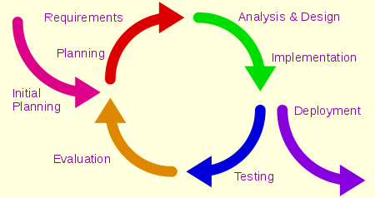

## UML Diagrams

Lets start with a simple use case diagrams

user types : basic users , contributors, maintainers, admins

This diagram below shows what can a simple / basic user do (all the website users)

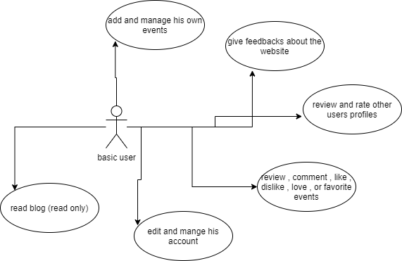

The Contirubutor is basic user who can do more as this use case diagram below show

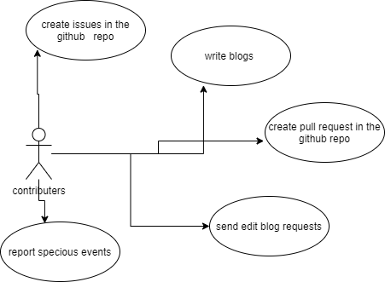

Maintainers are those who manage the github team and pull request , they can create new projects to solve new problems in the ibn khaldoune university

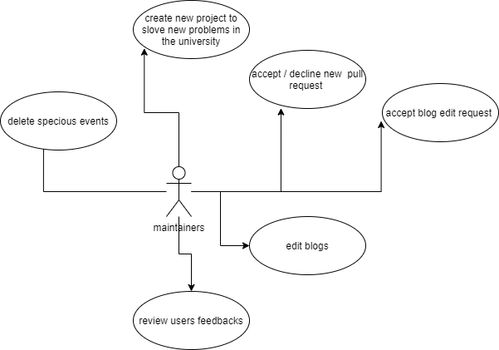

finally admins

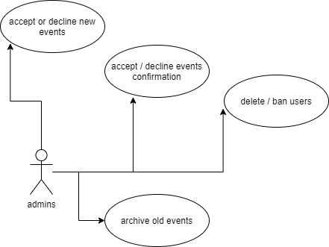

The picture below shows a class diagram representing the four different users

# 

In this picture below we can see how a user can create new events

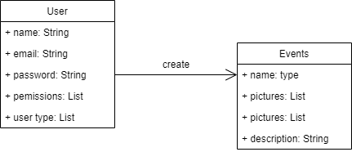

# Milestones

## Lorem ipsum

Lorem ipsum dolor sit amet, consectetuer adipiscing elit, sed diam nonummy nibh euismod tincidunt ut laoreet dolore magna aliquam erat volutpat.

## Dolor sit amet

Lorem ipsum dolor sit amet, consectetuer adipiscing elit, sed diam nonummy nibh euismod tincidunt ut laoreet dolore magna aliquam erat volutpat.